Web Designing Assignment

Term-1

Module(HTML)-1

**1: Are the HTML tags and elements the same things?**

**Answer:** NO …HTML tags are used to define the structure of the content, while elements are the actual building blocks.

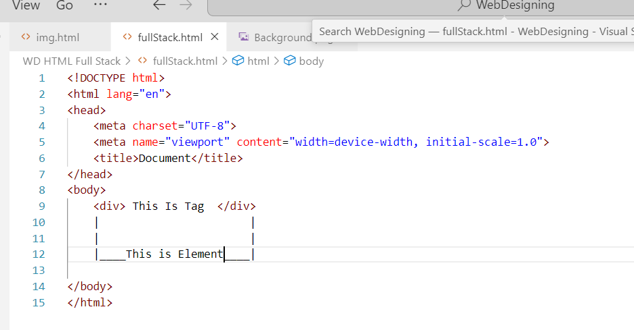

<tr></tr> and <div></div> that are a tags.

Eg <tr></tr>

<div></div>

we can write in tag that called elements

Eg <p> This Is Paragraph </p>

<tr> information form </tr>

**2: what are tags and attributes in html?**

**Answer**: HTML tags are used to define the elements within a web page, such as headings, paragraphs, and images. Tags are enclosed in angle brackets, and usually come in pairs, with a start tag and an end tag. For example, the paragraph tag is written as <p> and </p>. The content of the paragraph goes between the opening and closing tags.

Attributes provide additional information about the tag. They are used to specify things like the source of an image or the target of a link. Attributes are added to the opening tag, and consist of a name and a value, separated by an equals sign. For example, the image tag might include an attribute like src="image.jpg" to specify the location of the image file.

This are html tags

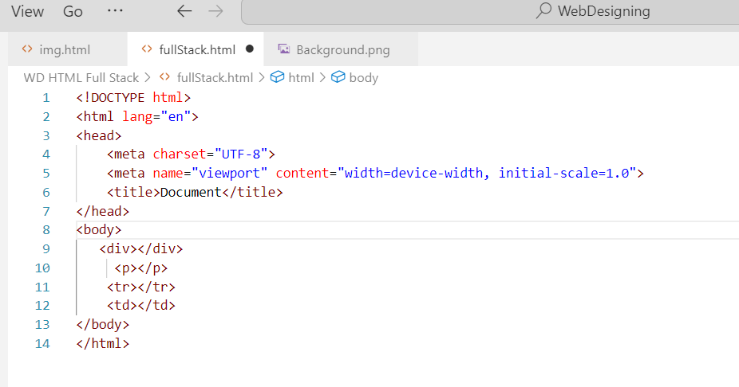

This is html elements

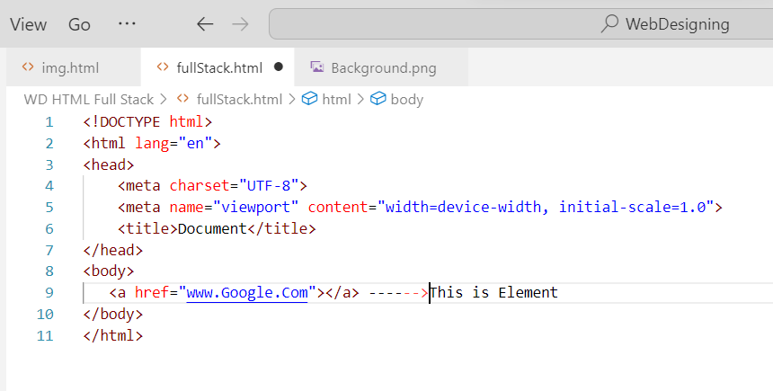

**3: what are void elements in html?**

**Answer**: Void elements are HTML elements that don't have any content. They are self-closing and are written with an empty tag, like <br> or <img>. Since they don't have any content, there is no need for a closing tag. Void elements are used to insert things like line breaks, images, and other content that doesn't need to be enclosed by a tag.

an element that has only opning tag they has not closing tag that called void element

<img> tag and <br>

>tag are that tag are only start the tag are not a end so that are avoid element

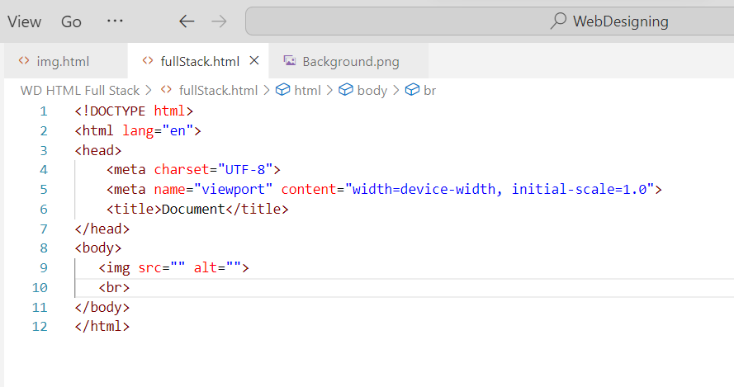

**4: what is Html entities?**

**Answer:** Html entities are used to represent symbols.

Html entities start with ‘&’ .

|  |  |  |
| --- | --- | --- |
| **Entities** | **Description** | **value** |
| &nbsp; | Space |  |
| &It; | Lase-thane | < |
| &gt; | Greater-thane | > |
| &quot; | Double-question mark | “ |
| &apos; | Single-question mark | ‘ |
| &pound; | Pound | £ |
| &dollar | dollar | $ |

**5: what are the different types of lists in html?**

**Answer**:

Types of lists in HTML:-

|  |  |
| --- | --- |
| **List of types** | **Define** |
| <ol> | For numbers |
| <ul> | For symbols |
| <dl> | For Description |

There are three types

1 order list

2 unorder list

3 Description list

**Order list**

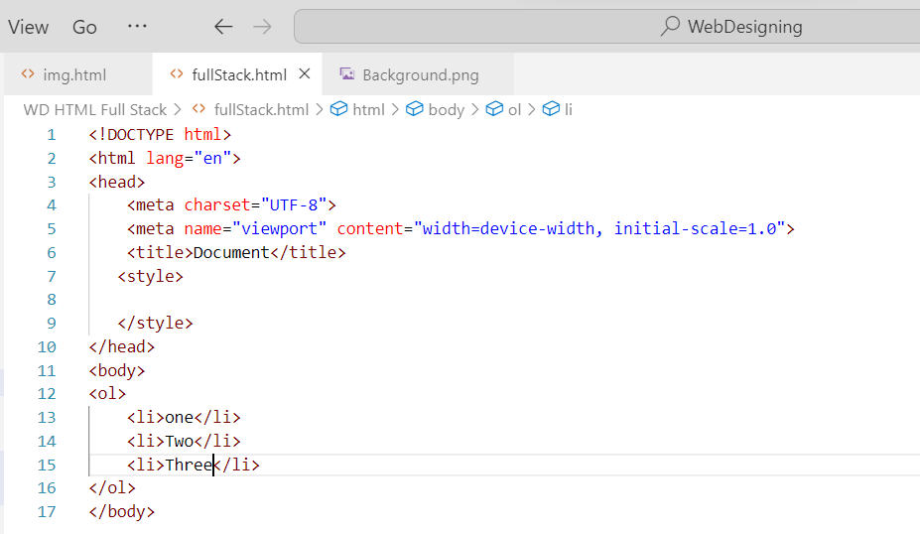

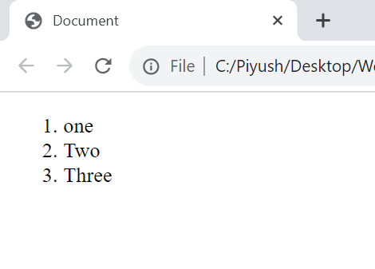

**Unorder list**

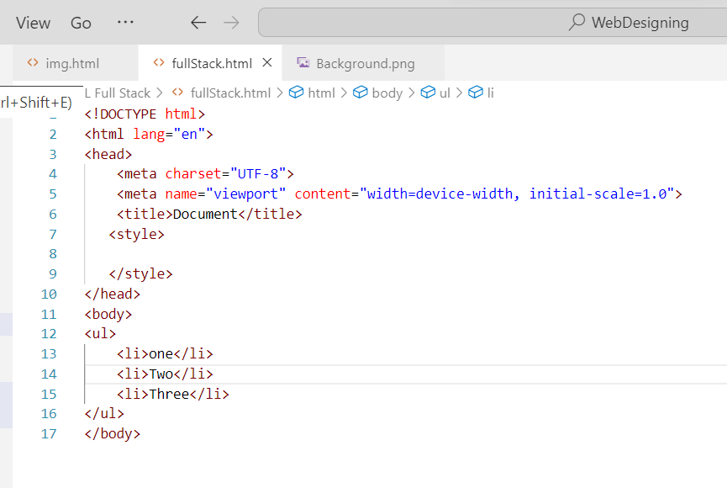

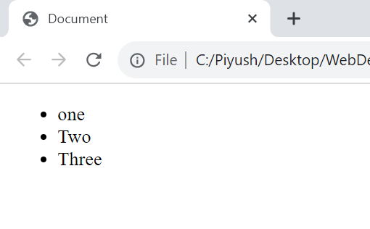

Description list

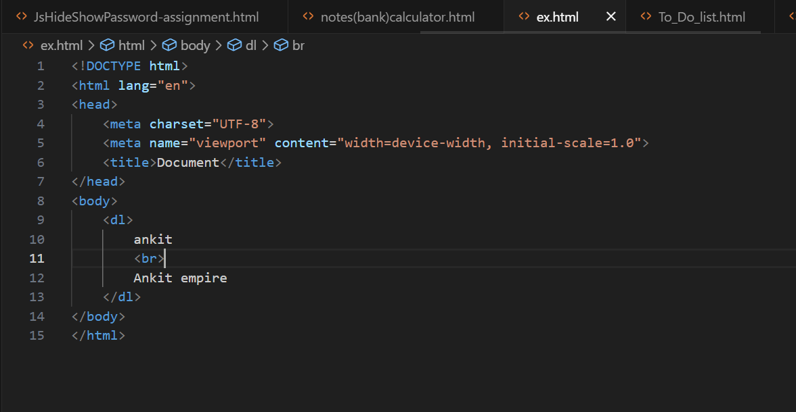

**6: what is the ‘class’ attribute in html?**

**Answer**: The "class" attribute in HTML is used to define a class for an HTML element. It is used to group together elements with similar styles or functionality, and can be used to apply a CSS style to multiple elements at once.

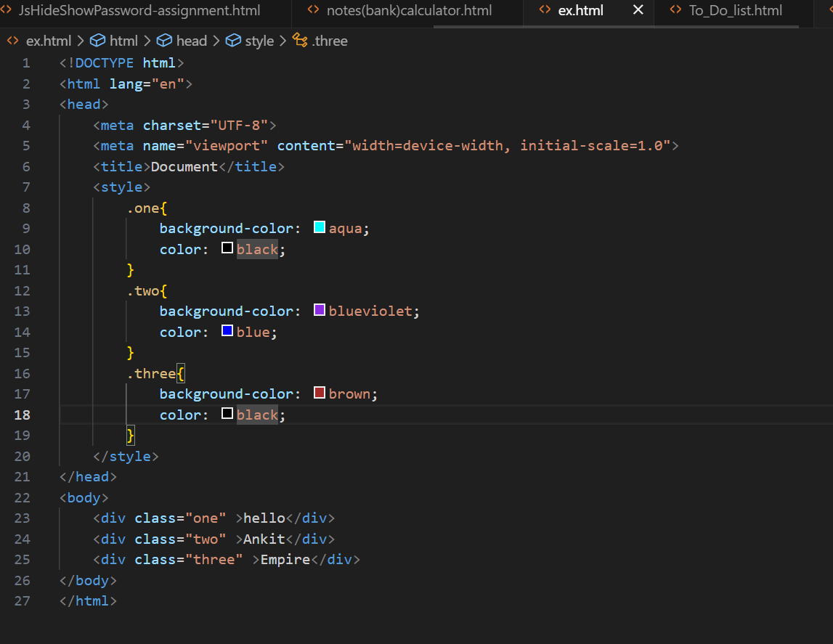

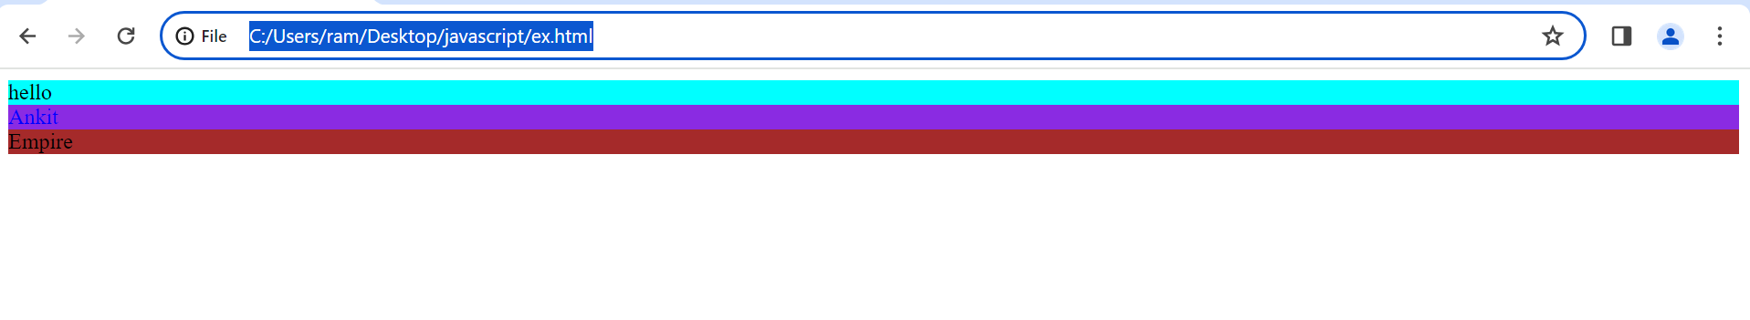

**7: what is the difference between the ‘id’ Attribute and the ‘class’ attribute of html elements.**

**Answer**: The "id" attribute in HTML is used to uniquely identify an element on a page. It must be unique within the page, and is often used to create links or to apply styles to a specific element. The "class" attribute, on the other hand, is used to group together elements with similar styles or functionality. Multiple elements can share the same "class" attribute, and a single element can have multiple classes. The "class" attribute is often used to apply a CSS style to multiple elements at once.

a class is a use of multiple html element . while id is a use of one html element.

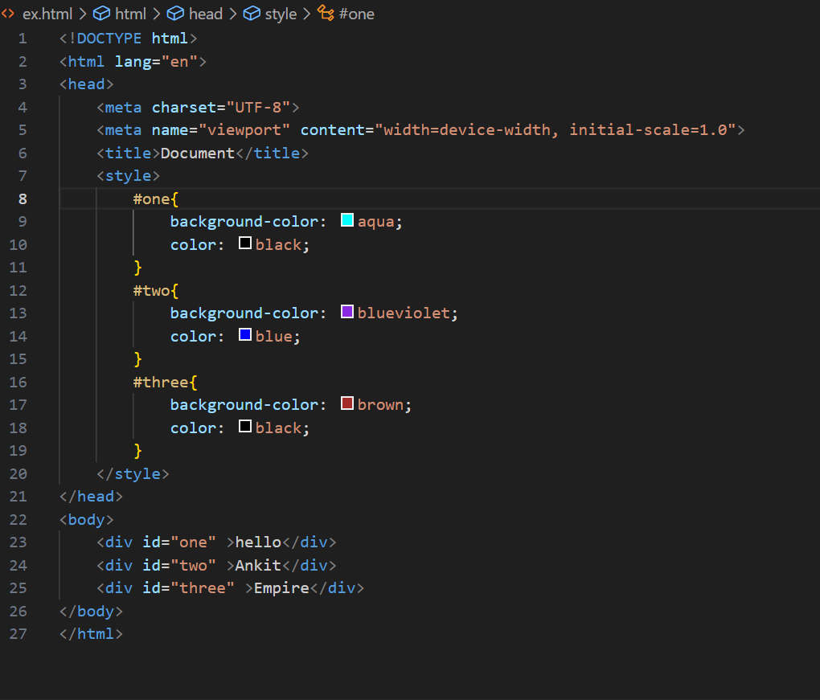

**8: what are the various formatting tags in html?**

**Answer**: Here is a brief description of some of the most commonly used formatting tags in HTML

-Heading tags (h1-h6): These tags are used to define headings and subheadings on a page. The h1 tag is used for the main heading, and the h2-h6 tags are used for subheadings.

- Paragraph tag (p): This tag is used to define a paragraph of text.

- Bold tag (b): This tag is used to make text bold.

- Italic tag (i): This tag is used to make text italic.

- Underline tag (u): This tag is used to underline text.

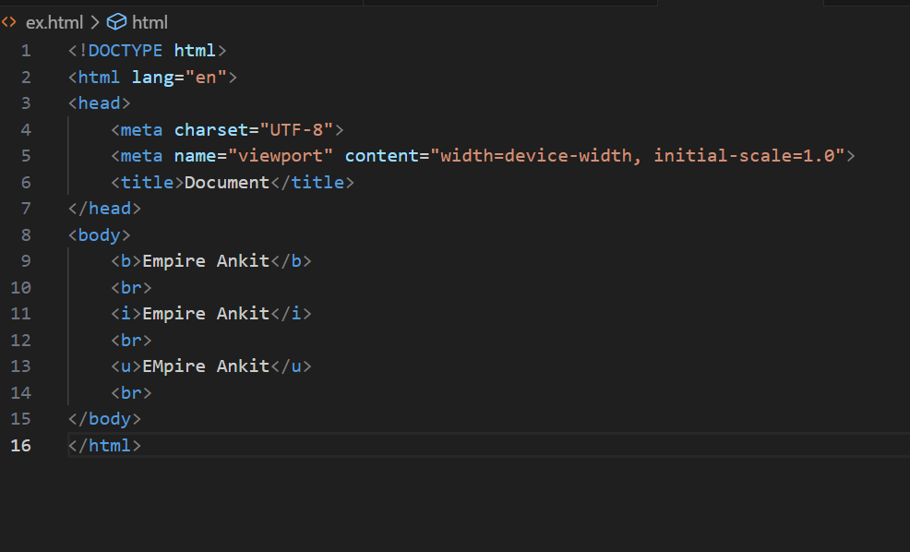

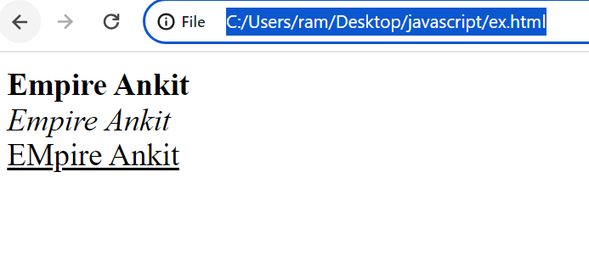

**9: How is cell padding different from cell spacing?**

**Answer:** Cellpadding basically defines the space present between a table cell's border and the content present in it. Cellspacing basically defines the space present between individual adjacent cells.

cell padding is a specifies amount between the border of table and its contents

Cell spacing is a space between the content in table

Normal

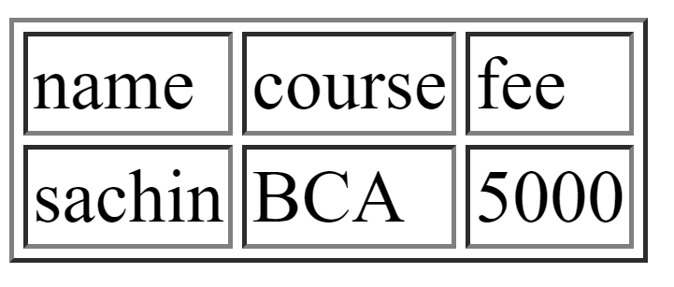

Cell spacing

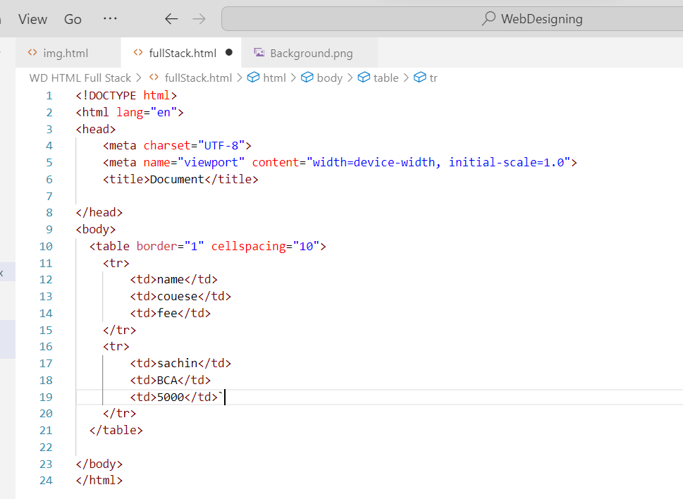

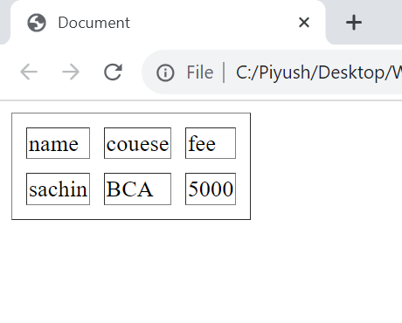

Cell padding

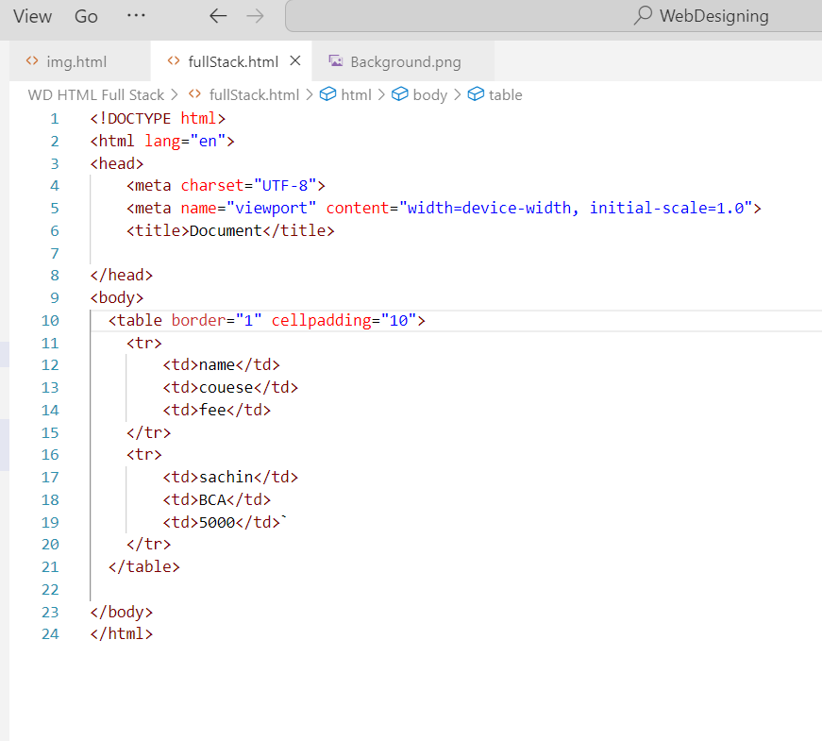

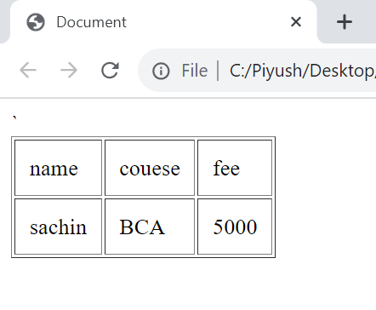

**10: How can we club two or more rows or columns into a single row or column in an HTML table?**

**Answer**: To club two or more rows or columns into a single row or column in an HTML table, you can use the "rowspan" or "colspan" attribute on the appropriate table cell. The "rowspan" attribute specifies the number of rows that a cell should span, while the "colspan" attribute specifies the number of columns that a cell should span. For example, to span two rows in a table cell, you would use the following code:

<td rowspan="2">Cell content</td>

Similarly, to span two columns in a table cell, you would use the following code:

<td colspan="2">Cell content</td>

Example:

<!DOCTYPE html>

<html lang="en">

<head>

    <meta charset="UTF-8">

    <meta name="viewport" content="width=device-width, initial-scale=1.0">

    <title>Student Registration Form</title>

</head>

<body>

    <style>

        body{

            background-image: url();

            background-repeat: no-repeat;

            background-size: 100px;

            background-attachment: fixed;

        }

    </style>

    <table border="1">

        <th align="center" colspan="2"><h2>Student Registration Form</h2></th>

        <form action="">

            <tr>

                <td><b><label for="">First Name</label></b></td>

                <td><input type="text"

                    ></td>

            </tr>

            <tr>

                <td><b><label for="">Last Name</label></b></td>

                <td><input type="text"></td>

            </tr>

            <tr>

                <td><b><label for="">Date of Birth</label></b></td>

                <td><input type="date"></td>

            </tr>

            <tr>

                <td><b><label for="">Email Id</label></b></td>

                <td><input type="email"></td>

            </tr>

            <tr>

                <td><b><label for="">Mobile Number</label></b></td>

                <td><input type="text"></td>

            </tr>

            <tr>

                <td><b><label for="">Gender</label></b></td>

                <td> <label for="">Male </label>

                    <input type="radio" name="abc" id="">

                    <label for="">Female </label>

                    <input type="radio" name="abc" id=""></td>

            </tr>

            <tr>

                <td><b><label for="">Addres</label></b></td>

                <td><textarea name="" id="" cols="20" rows="10"></textarea></td>

            </tr>

            <tr>

                <td><b><label for="">City</label></b></td>

                <td><input type="text"></td>

            </tr>

            <tr>

                <td></b><label for="">Pincode</label></b></td>

                <td><input type="text" name="" id=""></td>

            </tr>

            <tr>

                <td><label for="">State</label></b></td>

                <td><input type="text"></td>

            </tr>

            <tr>

                <td><b><label for="">Country</label></b></td>

                <td><input type="text" name="" id=""></td>

            </tr>

            <tr>

                <td><b></b><label for="">Hobbies</label></b></td>

               <td><input type="checkbox">Drawing

                <input type="checkbox">Singing

                <input type="checkbox">Dancing

                <input type="checkbox">Others

                <input type="text"></td>

            </tr>

            <tr>

                <td><b><label for="">Qualification</label></b></td>

                <td>

                    <table>

                        <tr>

                            <th>Sr No.</th>

                            <th>Examination</th>

                            <th>Board</th>

                            <th>Percentage</th>

                            <th>Year Of Passing</th>

                        </tr>

                        <tr>

                            <td>1</td>

                            <td>10<sup>th</sup>class</td>

                            <td><input type="text"></td>

                            <td><input type="text"></td>

                            <td><input type="text"></td>

                        </tr>

                        <tr>

                            <td>2</td>

                            <td>12<sup>th</sup>class</td>

                            <td><input type="text"></td>

                            <td><input type="text"></td>

                            <td><input type="text"></td>

                        </tr>

                        <tr>

                            <td>3</td>

                            <td>Graduation</td>

                            <td><input type="text"></td>

                            <td><input type="text"></td>

                            <td><input type="text"></td>

                        </tr>

                        <tr>

                            <td>4</td>

                            <td>Master</td>

                            <td><input type="text"></td>

                            <td><input type="text"></td>

                            <td><input type="text"></td>

                        </tr>

                    </table>

                </td>

            </tr>

            <tr>

                <td><b><label for="">Course Appiled For</label></b></td>

                <td><label for="">B.A</label>

                    <input type="radio" name="xyz" id="">

                    <label for="">BSC</label>

                    <input type="radio" name="xyz" id="">

                    <label for="">B.com</label>

                    <input type="radio" name="xyz" id="">

                    <label for="">BCA</label>

            </td>

            <tr>

                <td colspan="2" align="center">

                    <input type="submit" name="" id="">

                    <input type="reset" name="" id="">

                    </td>

            </tr>

            </tr>

        </form>

    </table>

</body>

</html>

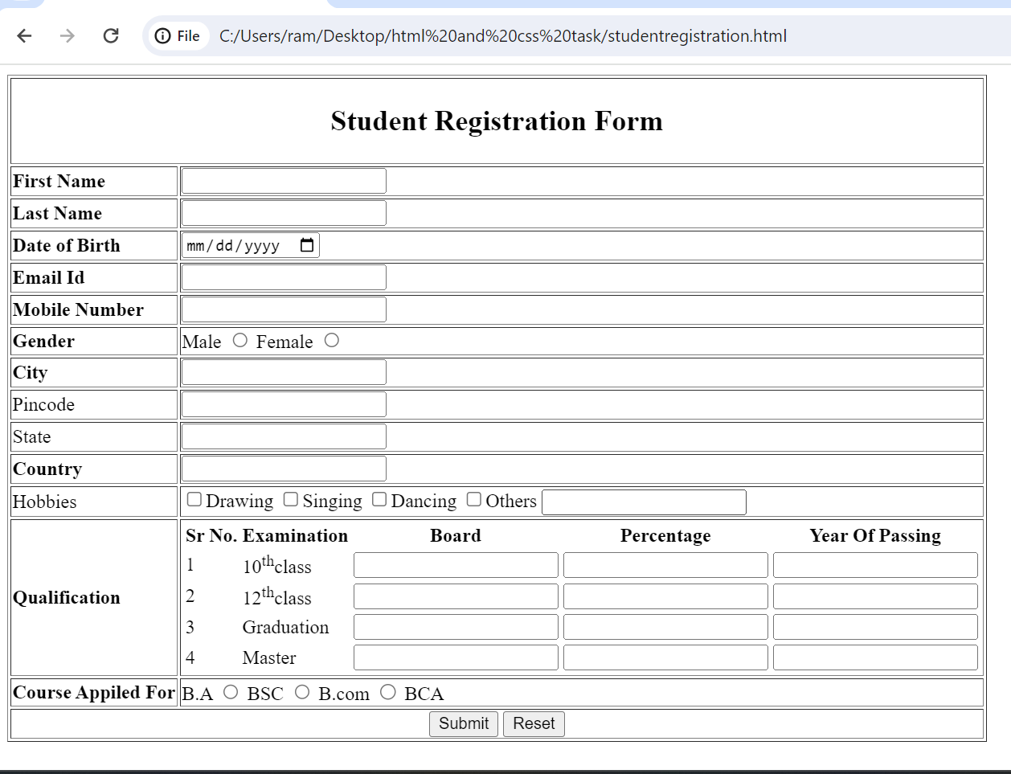

**11: What is the difference between a block-level element and an inline element?**

**Answer:** Block-level elements are HTML elements that take up the full width of their parent container and are displayed on a new line. Examples of block-level elements include <div>, <p>, <h1>-<h6>, <ul>, and <li>.

Inline elements, on the other hand, are HTML elements that only take up as much width as necessary and do not force a new line. Examples of inline elements include <span>, <a>, <strong>, <em>, and <img>.The primary difference between block-level and inline elements is how they are displayed on a web page. Block-level elements are used to create larger sections of content, while inline elements are used to add emphasis or to style smaller portions of text.

Inline element

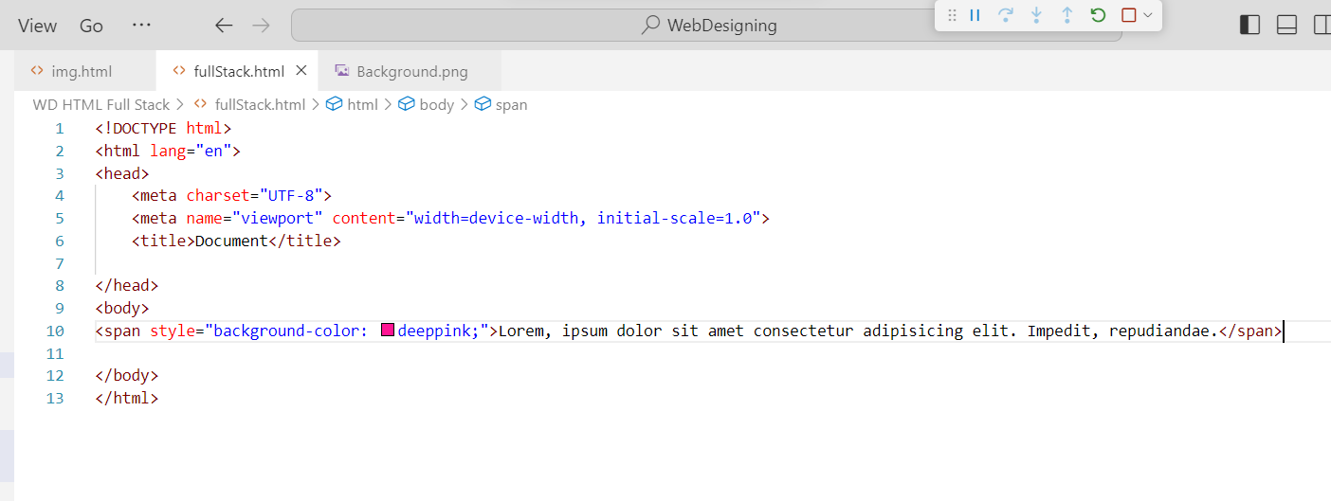

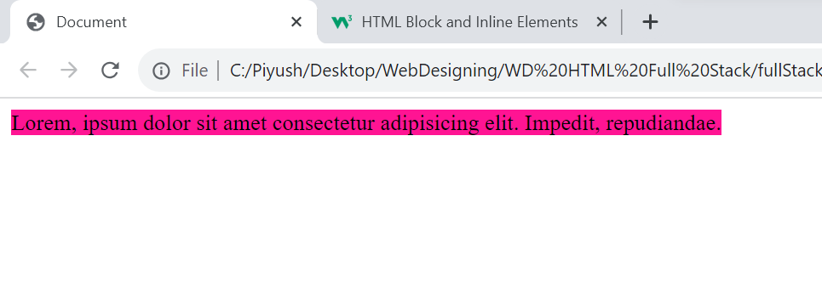

Block element

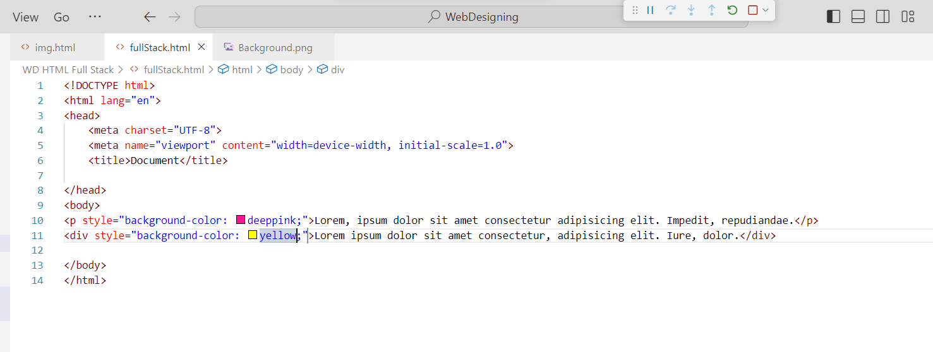

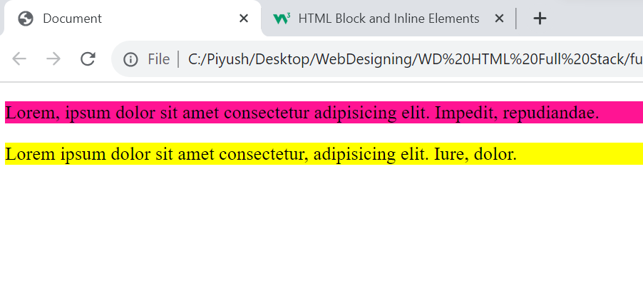

**12: How to Create a Hyperlink in Html?**

**Answer:** Using <a> tag create the hyperlink.

-<a> tag has 3 attributes {_blank, _parent, _top}

Ex. :-

<!DOCTYPE html>

<html lang="en">

<head>

    <meta charset="UTF-8">

    <meta http-equiv="X-UA-Compatible" content="IE=edge">

    <meta name="viewport" content="width=device-width, initial-scale=1.0">

    <title>Document</title>

</head>

<body>

    <a href="https://maps.google.com/" target=”_blank”>new link</a>

</body>

</html>

Output:-

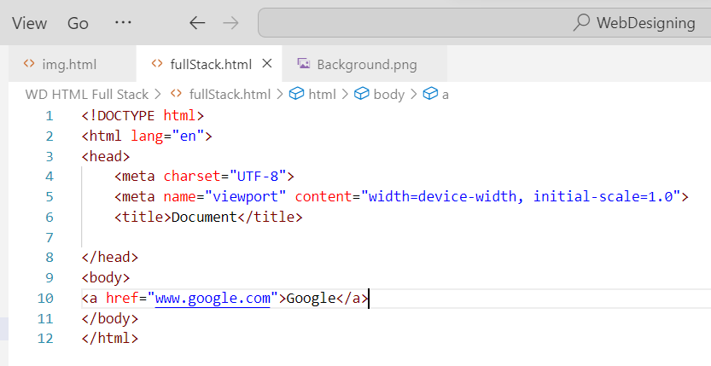

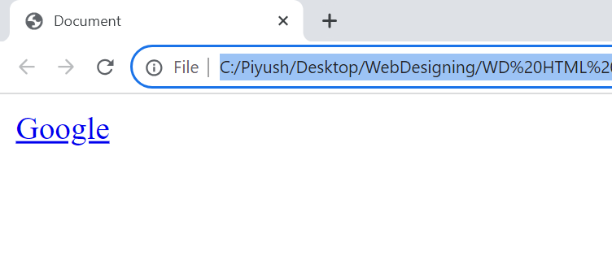

**13: what is the use of iframe tag?**

Answer: Iframe tag is specifies an ‘inline frame’. Inline frame is used to embed another document within the current HTML document.

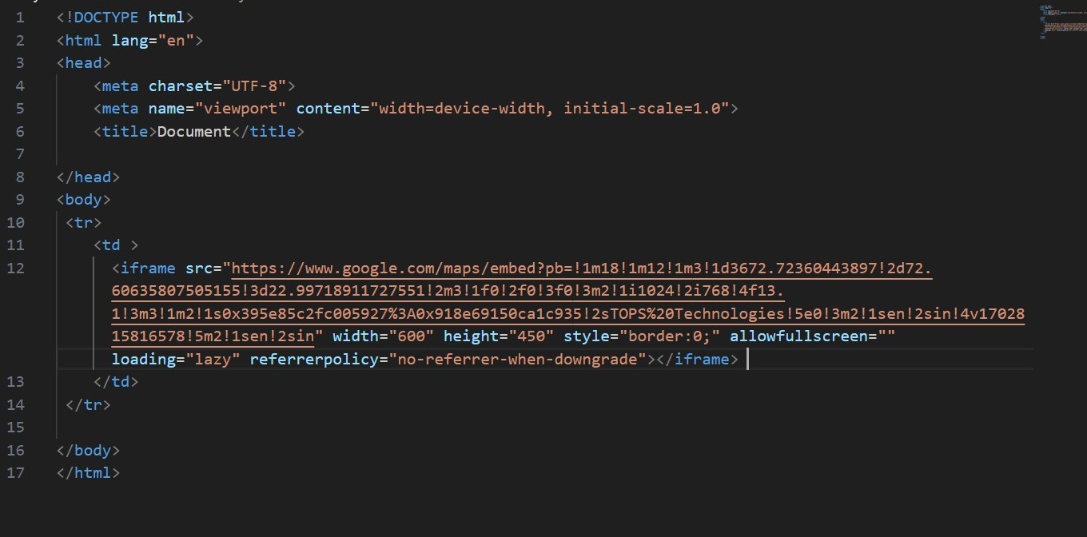



**14: what is the use of a span tag? Explain with Example?**

Answer: <span> tag is used for grouping and applying styles to inline elements.

-change the language of a part of the text.

-change the color, font, background of a part of text.

-can be used to group elements for styling purposes

Ex. :-

 <p>Lorem ipsum <span style="color: blue;"> dolor sit amet, consectetur</span> elit.</p>

Output: Lorem ipsum dolor sit amet, consectetur elit.

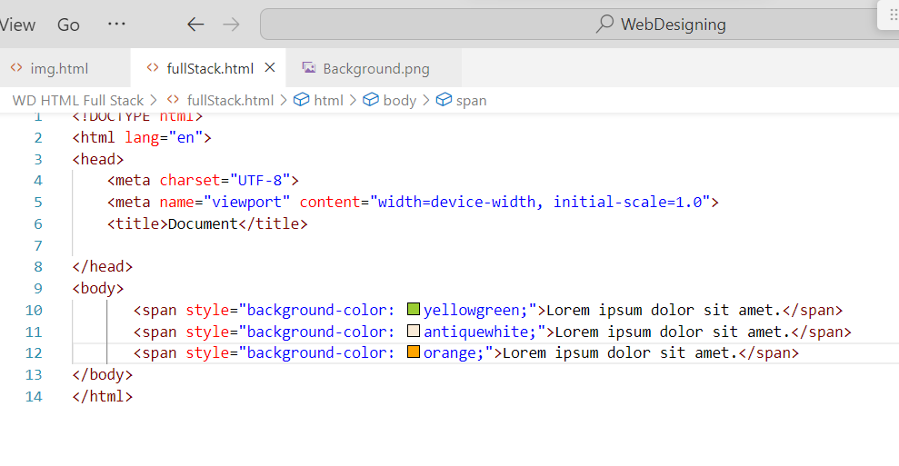

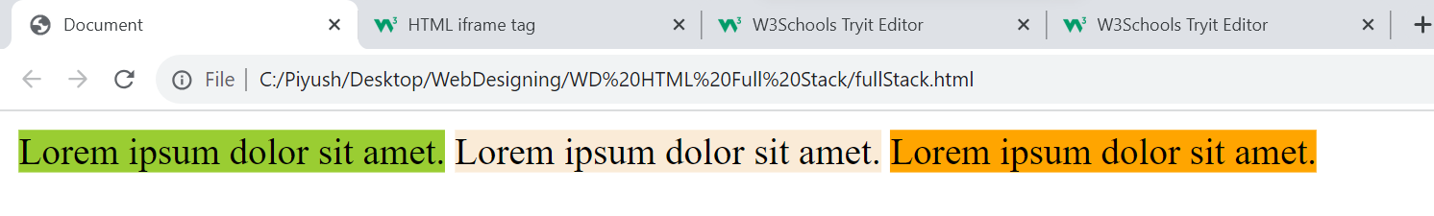

**15: How to insert a picture into a background image of a web page?**

**Answer:** Using <img src=”….”>tag you can insert the image in back-ground.

Ex. :-

 <img src="https://images.pexels.com/photos/516541/pexels-photo-516541.jpeg?auto=compress&cs=tinysrgb&w=600" alt="">

Output:

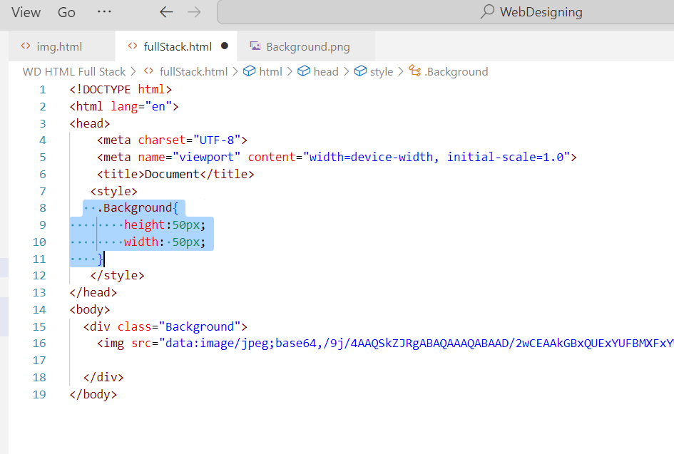



**16: How are active links different from normal links?**

**Answer:** Active Link:-

-Active link is clickable link.

Ex. :-

 <a href="1. Img.html">Ankit</a>

Output: Ankit

Normal Link:-

-Normal link is non Clickable link.

Ex. :-

 <a href="" >Ankit</a>

Output:- Ankit

Normal link

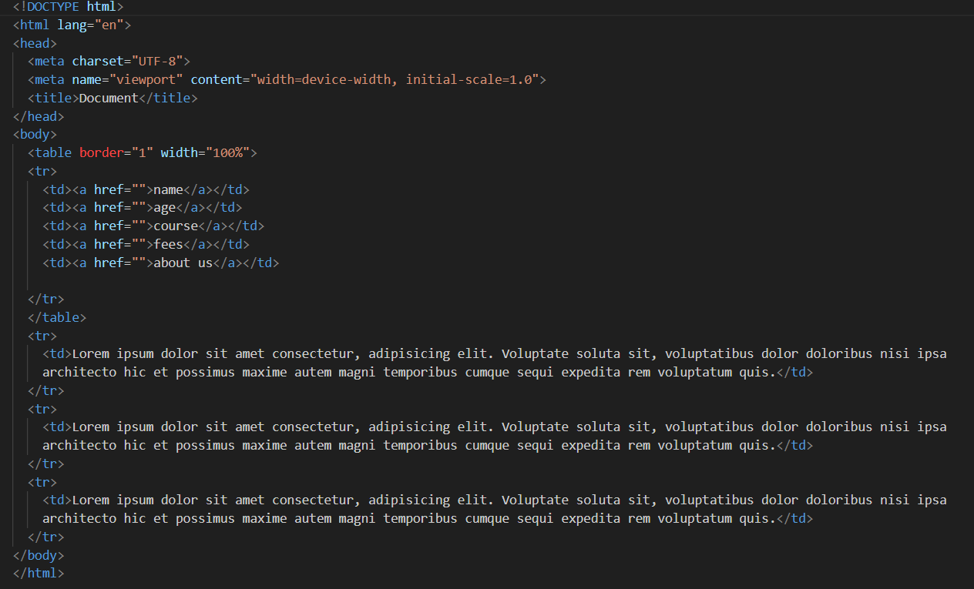

Active link

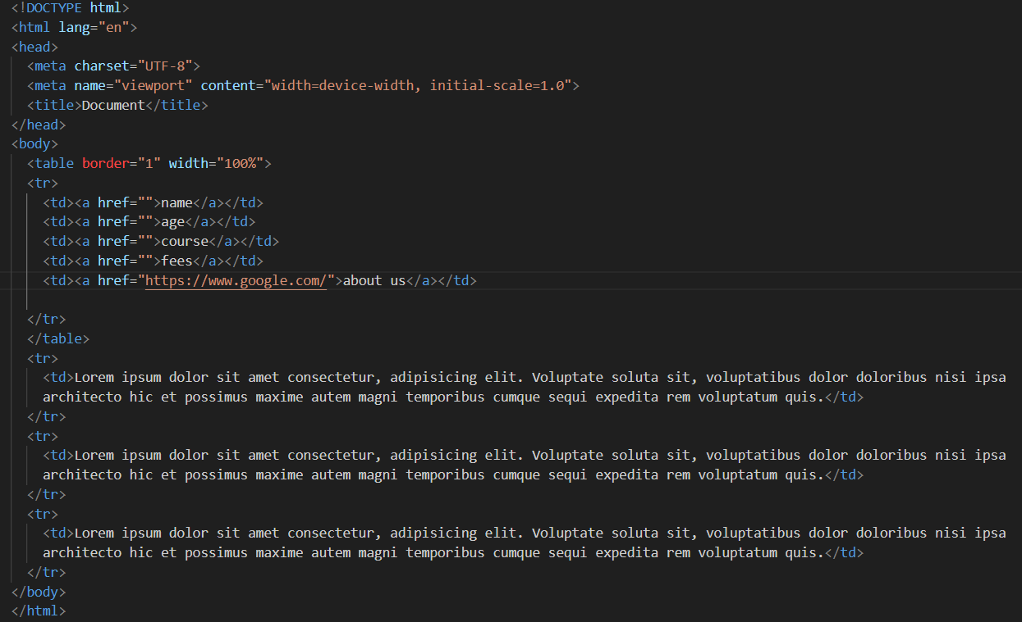

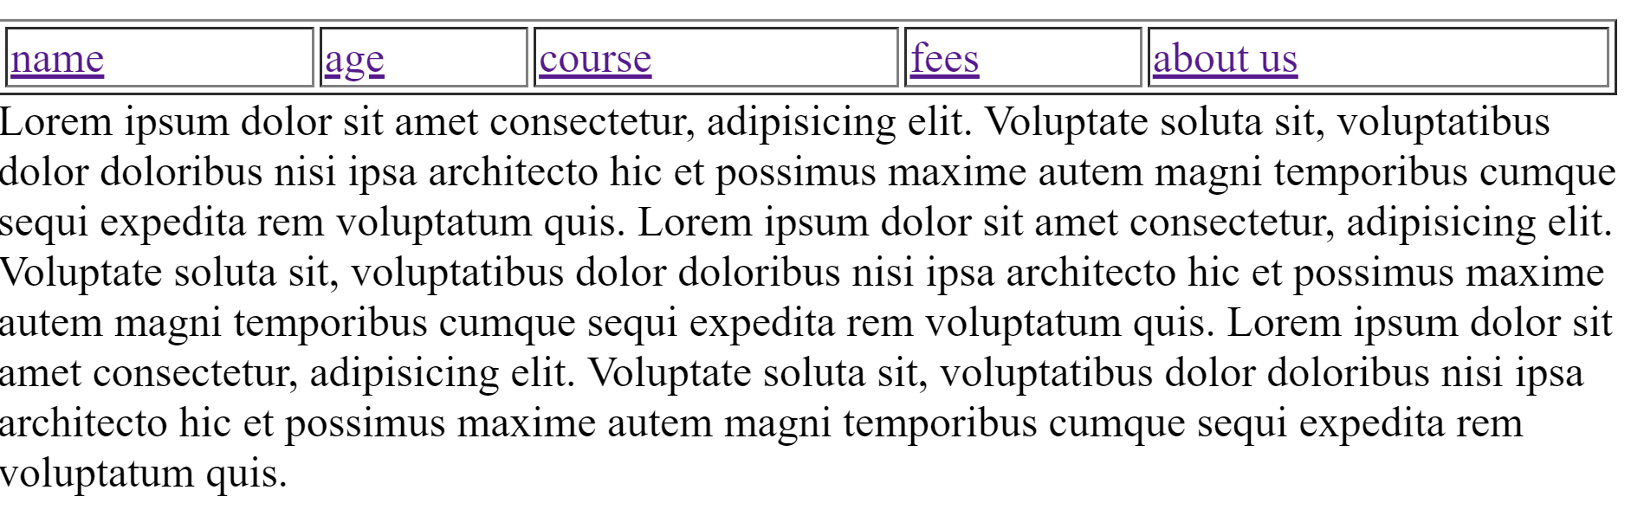

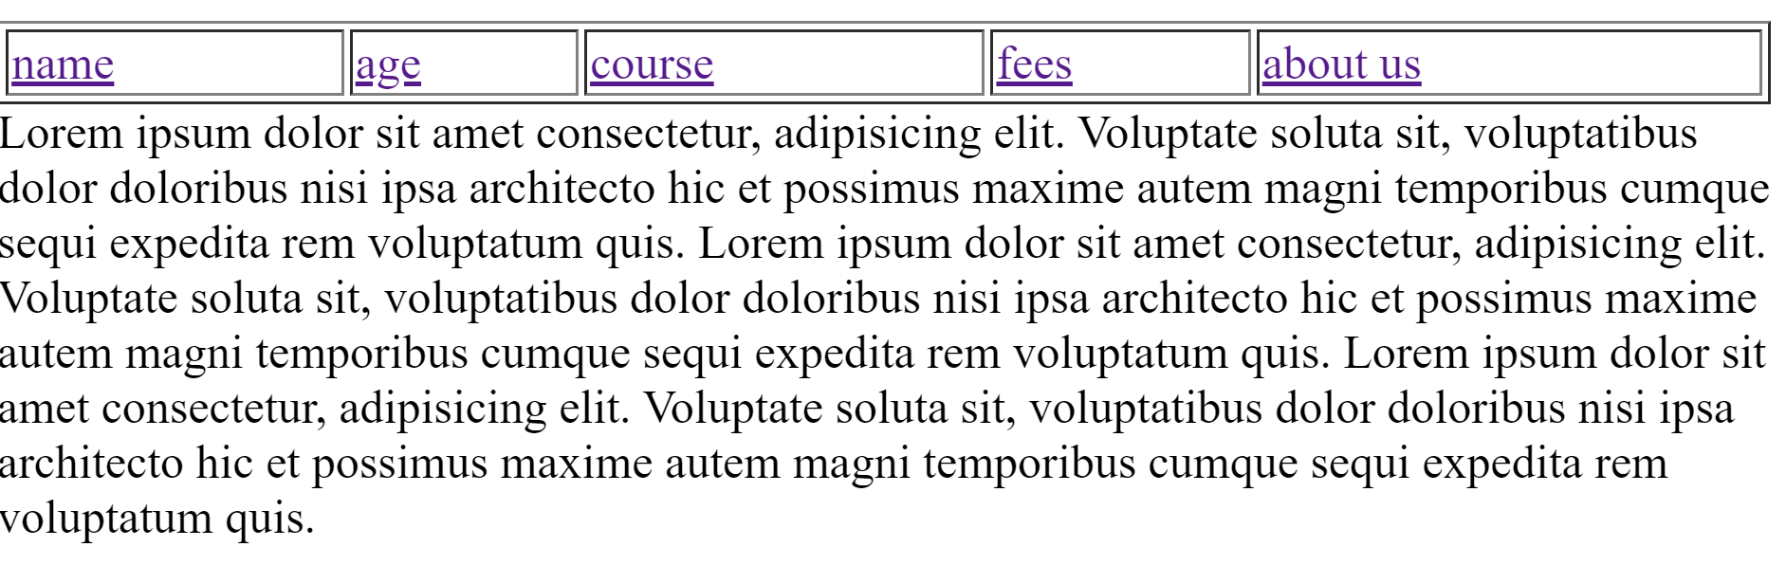



**17: what are the different tags to separate sections of text?**

**Answer:**

<p> Define the paragraph.

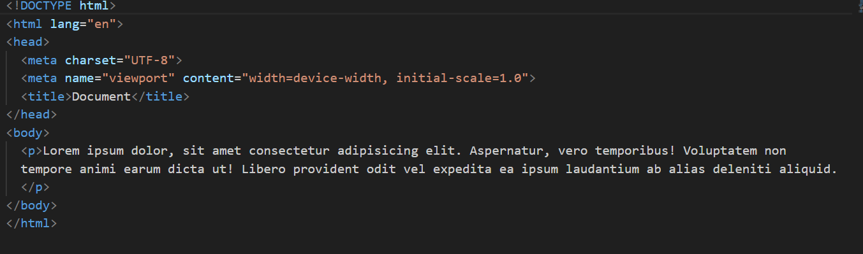

<br> Break the line before or after line.

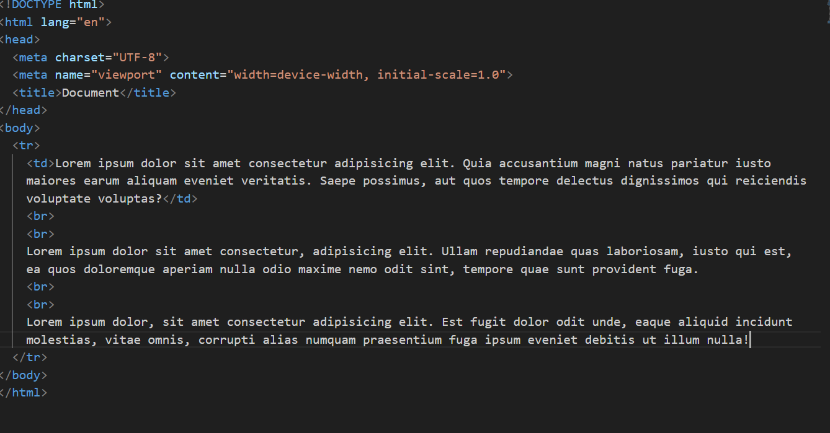

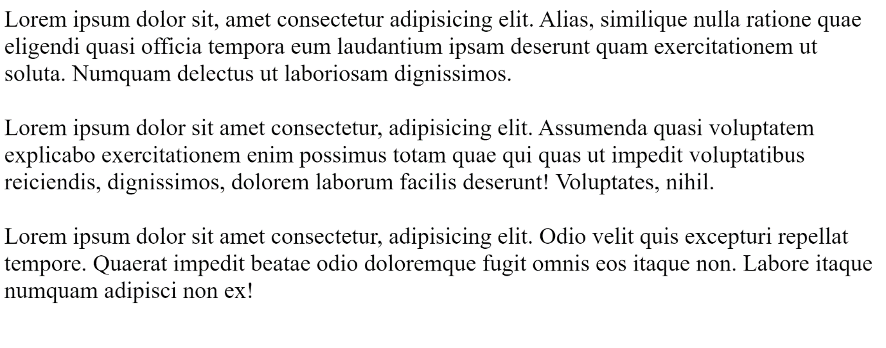

18: what is SVG?

Answer: SVG is scalable Vector Graphics.

-SVG is one type of Image.

-SVG is is an XML-based vector graphics.

-SVG image can be create and edit using vector graphics software.

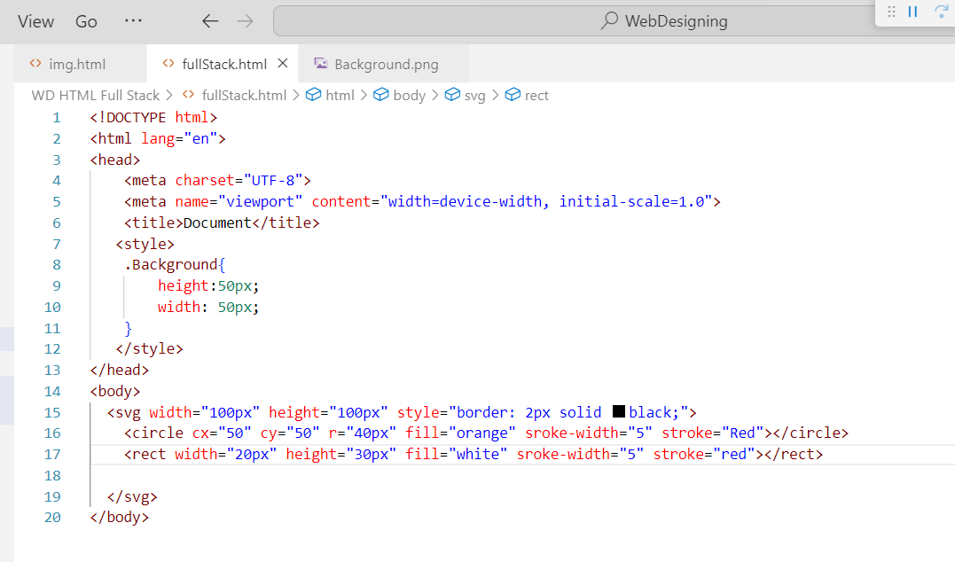

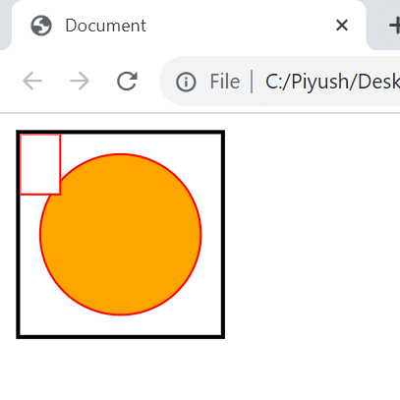

**19: what is difference between Html and XHtml?**

**Answer:**

|  |  |
| --- | --- |
| HTML | XHTML |
| Html stands for hypertext markup language.  HTML is in Document file format.  Html document do not require validation.  all tags and attributes are do not have to be in lower case or higher case. | Xhtml stands for Extensible hypertext markup language.  XHTML has Markup Language as the file format.  Xhtml documents must be required properly validation.  all tags and attribute are must be written in lowercase. |

**20: what are logical and physical tags in html?**

**Answer**: Logical Tags:-

-Logical tags are structure of the content.

-In logical tags <h1>…..<h6>, <p>, <ul>

Ex. :-

 <h1>prajapati</h1>

    <p>Param</p>

    <ul>Param</ul>

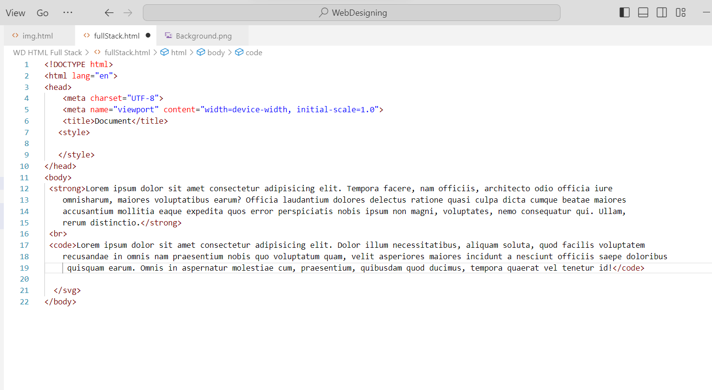

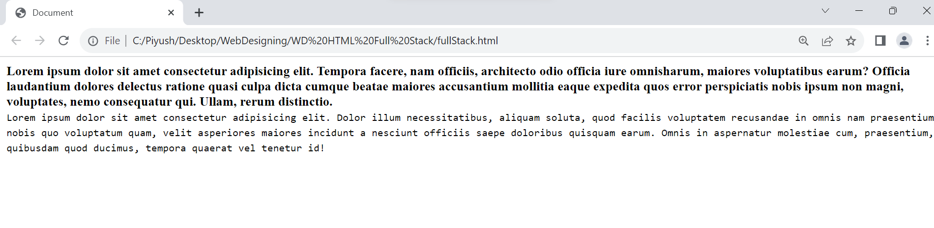

Physical Tags:-

-Physical tag are Presentation of the Content.

-In Physical tags <b>,<strong>,<i>,<u>

Ex. :-

<b>Bold</b><br>

<strong>strong</strong><br>

<i>Lorem</i><br>

<u>Underline</u><br>

